**Insertion Sort**

Pseudocode:

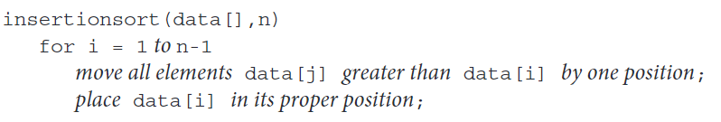

Implementation:

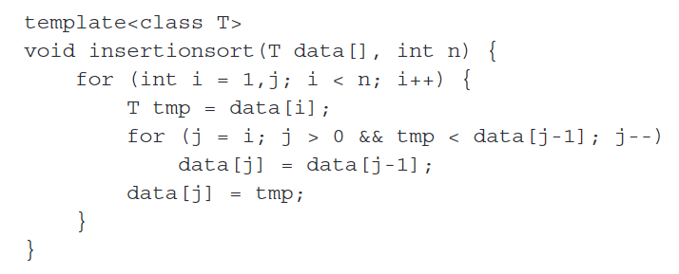

**Selection Sort**

Pseudocode:

Implementation:

Improvement:

**Bubble Sort**

Pseudocode:

Implementation:

Improvement:

**Comb Sort**

Implementation:

**Shell Sort**

Pseudocode:

Implementation:

**Heap Sort**

Pseudocode:

Implementation:

**Quick Sort**

Pseudocode:

Implementation:

**Merge Sort**

Pseudocode:

mergesort() and merge() functions changed:

Implementation: